IWP Assignment

Code:

Index.html

<!DOCTYPE html>

<html lang="en">

<head>

     <meta charset="UTF-8">

     <meta name="viewport" content="width=device-width, initial-scale=1.0">

     <title>Greet User</title>

     <script>

        function greetUser() {

            var name = document.getElementById('nameInput').value;

            var designation = document.getElementById('designationInput').value;

            var xhr = new XMLHttpRequest();

            xhr.open("POST", "greet.php", true);

            xhr.setRequestHeader("Content-Type", "application/x-www-form-urlencoded");

            xhr.onreadystatechange = function() {

                if (xhr.readyState === XMLHttpRequest.DONE) {

                    document.getElementById('greeting').innerHTML = xhr.responseText;

                }

            };

             xhr.send("name=" + encodeURIComponent(name) + "&designation=" + encodeURIComponent(designation));

            }

    </script>

</head>

<body>

    <h1>Enter your name and designation to be greeted</h1>

    <input type="text" name="name" id="nameInput" placeholder="Enter your name" required>

    <input type="text" name="designation" id="designationInput" placeholder="Enter your designation" required>

    <button onclick="greetUser()">Greet Me!</button>

    <div id="greeting"></div>

</body>

</html>

Greet.html

<?php

if ($_SERVER["REQUEST_METHOD"] == "POST") {

    $name = isset($_POST['name']) ? htmlspecialchars($_POST['name']) : '';

    $designation = isset($_POST['designation']) ? htmlspecialchars($_POST['designation']) : '';

    if (!empty($name) && !empty($designation)) {

        echo "Hello, " . $name . "! Your designation is:  " . $designation . ".";

    } else {

         echo "Enter the name and designation.";

        }

} else {

    echo "Invalid request.";

}

?>

Output:

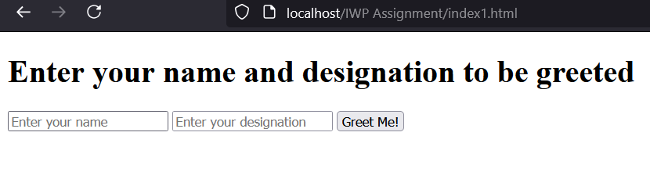

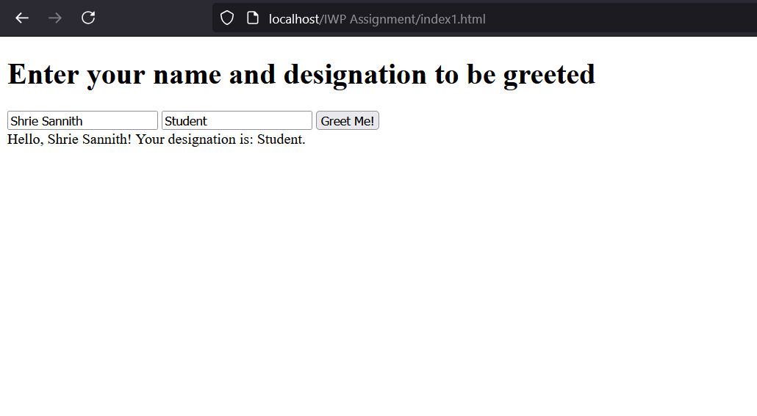

2.

**Index.html**  
  
<!DOCTYPE html>

<html lang="en">

<head>

    <meta charset="UTF-8">

    <meta name="viewport" content="width=device-width, initial-scale=1.0">

    <title>Database Operations</title>

    <script>

        function insertData() {

            var value = document.getElementById("insertInput").value;

            var xhr = new XMLHttpRequest();

            xhr.open("POST", "insert.php", true);

            xhr.setRequestHeader("Content-Type", "application/x-www-form-urlencoded");

            xhr.onreadystatechange = function() {

                if (xhr.readyState === XMLHttpRequest.DONE) {

                    alert(xhr.responseText); // Show response message

                    fetchRecords(); // Refresh the records list

                }

            };

            xhr.send("value=" + encodeURIComponent(value));

        }

        function fetchRecords() {

            var xhr = new XMLHttpRequest();

            xhr.open("GET", "fetch.php", true);

            xhr.onreadystatechange = function() {

                if (xhr.readyState === XMLHttpRequest.DONE) {

                    document.getElementById("records").innerHTML = xhr.responseText;

                }

            };

            xhr.send();

        }

        function deleteRecord(id) {

            var xhr = new XMLHttpRequest();

            xhr.open("POST", "delete.php", true);

            xhr.setRequestHeader("Content-Type", "application/x-www-form-urlencoded");

            xhr.onreadystatechange = function() {

                if (xhr.readyState === XMLHttpRequest.DONE) {

                    alert(xhr.responseText); // Show response message

                    fetchRecords(); // Refresh the records list

                }

            };

            xhr.send("id=" + id);

        }

        // Fetch records on page load

        window.onload = function() {

            fetchRecords();

        }

    </script>

</head>

<body>

    <h1>Database Operations</h1>

    <!-- Insert Form -->

    <div>

        <label for="insertInput">Insert Value:</label>

        <input type="text" id="insertInput" placeholder="Enter value to insert" required>

        <button onclick="insertData()">Insert</button>

    </div>

    <h2>Records:</h2>

    <div id="records">

        <!-- Records will be displayed here -->

    </div>

</body>

</html>

**Fetch.php**

<?php

$host = 'localhost';

$username = 'root';

$password = '';

$database = 'example_db';

$conn = new mysqli($host, $username, $password, $database);

if ($conn->connect_error) {

    die("Connection failed: " . $conn->connect_error);

}

$sql = "SELECT * FROM records";

$result = $conn->query($sql);

if ($result->num_rows > 0) {

    echo "<table border='1' cellpadding='10' cellspacing='0'>";

    echo "<tr><th>ID</th><th>Value</th><th>Action</th></tr>";

    while ($row = $result->fetch_assoc()) {

        echo "<tr id='record_" . $row['id'] . "'>";

        echo "<td>" . $row['id'] . "</td>";

        echo "<td>" . $row['value'] . "</td>";

        echo "<td><button onclick='deleteRecord(" . $row['id'] . ")'>Delete</button></td>";

        echo "</tr>";

    }

    echo "</table>";

} else {

    echo "No records found.";

}

$conn->close();

?>

**Insert.php**

<?php

// insert.php - Insert data into the database

$host = 'localhost';

$username = 'root'; // Replace with your database username

$password = ''; // Replace with your database password

$database = 'example_db';

$conn = new mysqli($host, $username, $password, $database);

// Check for connection errors

if ($conn->connect_error) {

    die("Connection failed: " . $conn->connect_error);

}

if (isset($_POST['value'])) {

    $value = htmlspecialchars($_POST['value']); // Sanitize input

    $stmt = $conn->prepare("INSERT INTO records (value) VALUES (?)");

    $stmt->bind_param("s", $value);

    if ($stmt->execute()) {

        echo "Record inserted successfully.";

    } else {

        echo "Error: " . $stmt->error;

    }

    $stmt->close();

}

$conn->close();

?>

**Delete.php**

<?php

// delete.php - Delete a record from the database

$host = 'localhost';

$username = 'root'; // Replace with your database username

$password = ''; // Replace with your database password

$database = 'example_db';

$conn = new mysqli($host, $username, $password, $database);

// Check for connection errors

if ($conn->connect_error) {

    die("Connection failed: " . $conn->connect_error);

}

if (isset($_POST['id'])) {

    $id = (int) $_POST['id'];

    $stmt = $conn->prepare("DELETE FROM records WHERE id = ?");

    $stmt->bind_param("i", $id);

    if ($stmt->execute()) {

        echo "Record deleted successfully.";

    } else {

        echo "Error: " . $stmt->error;

    }

    $stmt->close();

}

$conn->close();

?>

